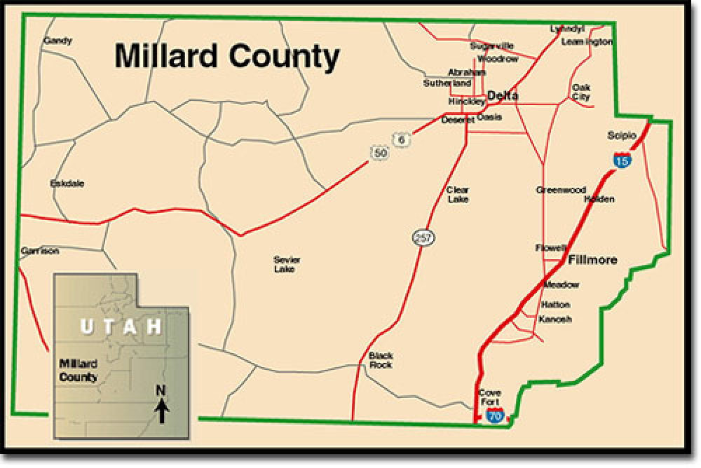
MILLARD COUNTY PLANNING COMMISSION
71 South 200 West, PO Box 854, Delta, UT 84624
Phone 435-864-1400 Fax 435-864-1404
Chairman David Sturlin Vice Chairman Joyce Barney
Peter Greathouse –Bob Rogers – John Nye – Demar Iverson – Erin Sorenson

DATE: April 29, 2022
TO: Millard County Planning Commission
FROM: David Sturlin, Chairman
SUBJECT: Millard County Planning Commission Meeting

Public Notice is hereby given that the Millard County Planning Commission will hold a public meeting at the Millard County Offices, 71 South 200 West, Delta, Utah commencing at 5:30 p.m. on Wednesday, May 4, 2022. All interested persons are invited to participate and make comment. If you would like to provide written comments, please email arichins@co.millard.ut.us.

AGENDA

- WELCOME, CALL TO ORDER – Chairman David Sturlin
- PUBLIC INPUT
- LAND USE TRAINING—Jordan Cullimore, Lead Attorney Office of the Property Rights
Ombudsman

- POSSIBLE CLOSED MEETING Pursuant To Utah Code Annotated Section 52-4-204 & 205
- APPROVAL OF MINUTES –Planning Commission Meetings March 2, 2022

- ADJOURNMENT
A copy of this agenda will serve as notice to all surrounding property owners of any proposed changes to zoning or land use.

In compliance with the Americans with Disabilities Act, individuals needing special accommodations (including auxiliary communicative aids and services) during this meeting should notify the Millard County Offices at 71 South 200 West, Delta, Utah 435 864-1400, at least three working days prior to the meeting.

CERTIFICATION OF POSTING
I, the Millard County Planner, do hereby certify that the above agenda was posted on the Utah State Public Notice website http://www.utah.gov/pmn/index.html, the Millard County Website www.millardcounty.org, and posted in three public places within Millard County on April 29, 2022. Adam Richins, Millard County Planner, arichins@co.millard.ut.us

