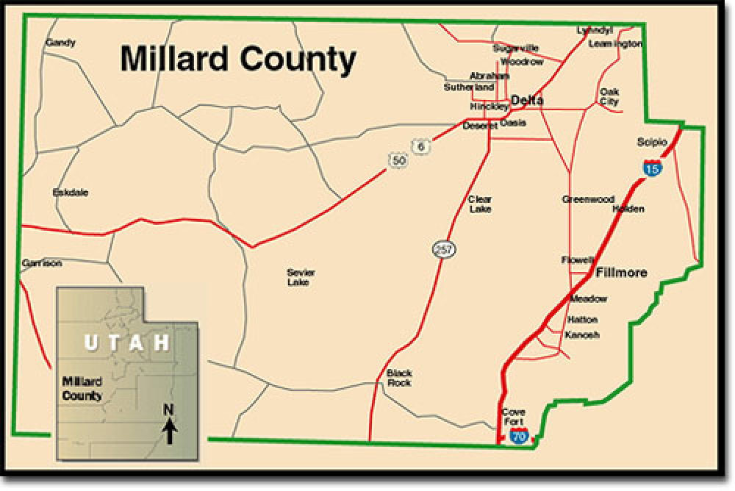
MILLARD COUNTY PLANNING COMMISSION
71 South 200 West, PO Box 854, Delta, UT 84624
Phone 435-864-1400 Fax 435-864-1404
Chairman David Sturlin Vice Chairman Joyce Barney
Peter Greathouse – John Nye – Demar Iverson – Erin Sorenson – Phil Morrison

DATE: April 24, 2023
TO: Millard County Planning Commission
FROM: David Sturlin, Chairman
SUBJECT: Millard County Planning Commission Meeting

Public Notice is hereby given that the Millard County Planning Commission will hold a public meeting at the Millard County Offices, 71 South 200 West, Delta, Utah commencing at 6:30 p.m. on Wednesday, May 3, 2023. All interested persons are invited to participate and make comment. If you would like to provide written comments, please email arichins@co.millard.ut.us.

AGENDA

- WELCOME, CALL TO ORDER – Chairman David Sturlin
- PUBLIC INPUT
- PUBLIC HEARING—Zoning Ordinance Map Amendment Application Z-2023-020 to change the zoning of property located approximately 2500 E Main Street Delta from Highway Commercial (HC) / Agriculture 20 (Ag-20) to Light Industrial (LI). Shane Church, Applicant
- REVIEW and POSSIBLE RECOMMENDATION – Zoning Ordinance Map Amendment Application Z-2023-020 to change the zoning of property located approximately 2500 E Main Street Delta from Highway Commercial (HC) / Agriculture 20 (Ag-20) to Light Industrial (LI).

- PUBLIC HEARING—C-1 Conditional Use Permit Application #Z-2023-022 for Temporary Construction Housing at approximately 2000 N Highway 6 Delta. WKW LLC, Owner/Applicant
- REVIEW and POSSIBLE RECOMMENDATION— C-1 Conditional Use Permit Application #Z-2023-022 for Temporary Construction Housing at approximately 2000 N Highway 6 Delta.
- PUBLIC HEARING—C-1 Conditional Use Permit Application #Z-2023-021 for Temporary Construction Housing at approximately 3450 S 4100 W Delta. Jason & Sam Edwards Owners/Applicants.
- REVIEW and POSSIBLE RECOMMENDATION— C-1 Conditional Use Permit Application #Z-2023-021 for Temporary Construction Housing at approximately 3450 S 4100 W Delta.
- OTHER BUSINESS
- POSSIBLE CLOSED MEETING Pursuant to Utah Code Annotated Section 52-4-204 & 205
- APPROVAL OF MINUTES –Planning Commission March 29, 2023
- ADJOURNMENT
A copy of this agenda will serve as notice to all surrounding property owners of any proposed changes to zoning or land use.

In compliance with the Americans with Disabilities Act, individuals needing special accommodations (including auxiliary communicative aids and services) during this meeting should notify the Millard County Offices at 71 South 200 West, Delta, Utah 435 864-1400, at least three working days prior to the meeting.

CERTIFICATION OF POSTING
I, the Millard County Planner, do hereby certify that the above agenda was posted on the Utah State Public Notice website http://www.utah.gov/pmn/index.html, the Millard County Website www.millardcounty.org, and posted in three public places within Millard County on April 24, 2023. Adam Richins, Millard County Planner, arichins@co.millard.ut.us

