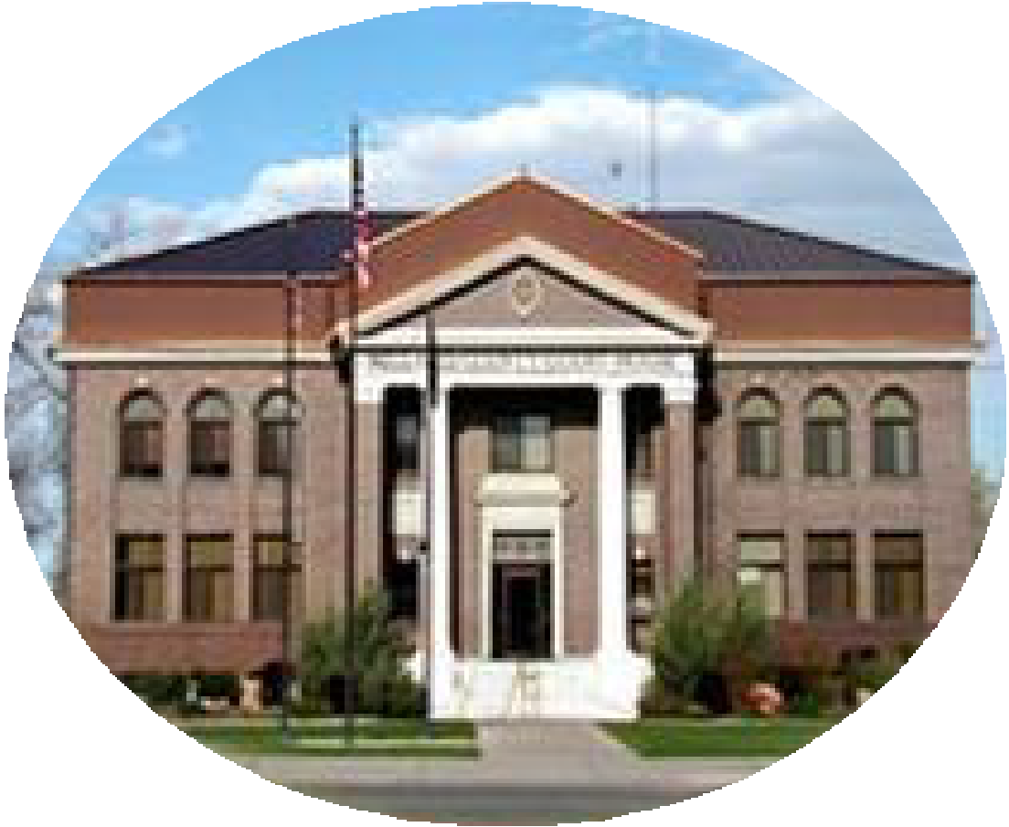
Courthouse - Fillmore  50 South Main  Fillmore, UT 84631-5504  Fax: (435) 743-8019  Commission Secretary:  (435) 743-6223  Fax: (435) 743-6923 |  | Millard County  www.millardcounty.org
Public Safety Building  765 South HWY, 99  Fillmore, UT 84631 |  | Millard County  www.millardcounty.org
Satellite Offices – Delta
71 South 200 West ◦ P.O. Box 854
Delta, UT 84624
Phone: (435) 864-1400
Fax: (435) 864-1404

Notice of Position for
Full-Time Deputy Assessor/DMV Manager in the Fillmore Office

Position Summary
The successful applicant will be responsible for performing all or some of the following duties:
- Manage the State Department of Motor Vehicles operations within the Fillmore office, including vehicle registrations and renewals; processing complex titles and registrations; handling mechanics’ liens, storage liens, and vehicle impounds.
- Prepare and review daily financial reports, reconcile daily receipts, and prepare bank deposits.
- Provide customer service to the public through in-person assistance and by answering incoming telephone calls.

The applicant will also perform a wide range of clerical duties, from entry-level to more complex tasks, to support the daily operations, projects, and requirements of the County Assessor’s Office. This position requires the ability to prioritize work effectively; communicate clearly and professionally both verbally and in writing; and develop and maintain productive working relationships with elected officials, professionals, members of the public, and fellow employees.

The successful candidate must be proficient in operating standard office equipment, including a 10-key calculator and computer, and demonstrate strong computer skills using Microsoft Windows and Microsoft Office applications such as Excel, Outlook, and Word. The position may require standing for extended periods of time on an occasional basis.

The applicant will assist the Assessor’s Office as needed. A more detailed list of duties and responsibilities is available upon request from the County Assessor.

Anyone who is interested in applying for this position must submit an application AND resume, with references, to Millard County Assessor’s Office, 50 South Main, Fillmore Utah or by email to hmiller@millardcounty.gov. by 12:00 pm on Friday, April 10, 2026.

Applications may be picked up at the Assessor’s office or online at www.millardcounty.gov

