Courthouse - Fillmore  50 South Main  Fillmore, UT 84631-5504  Fax: (435) 743-8019  Commission Secretary:  (435) 743-6223  Fax: (435) 743-6923 |  | Millard County  www.millardcounty.org
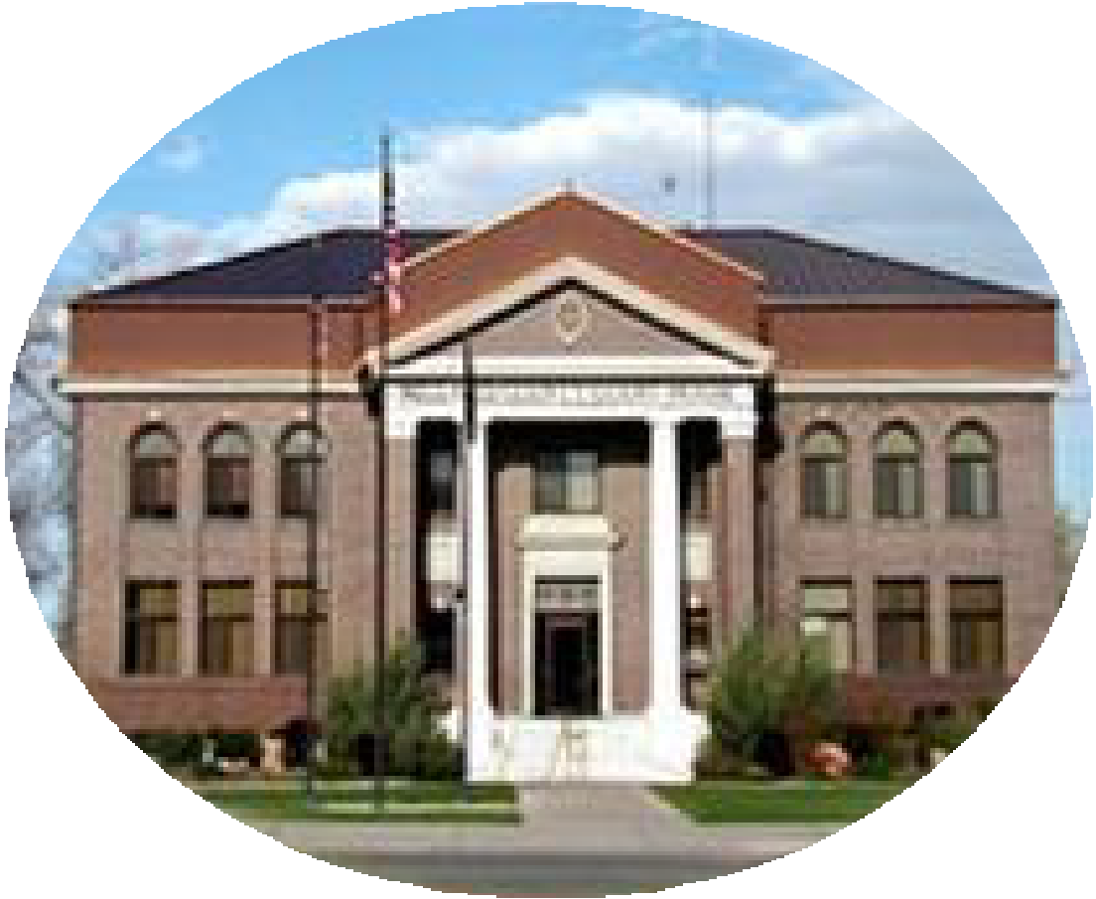 |  | Millard County  www.millardcounty.org
Satellite Offices – Delta
71 South 200 West ◦ P.O. Box 854
Delta, UT 84624
Phone: (435) 864-1400
Fax: (435) 864-1404
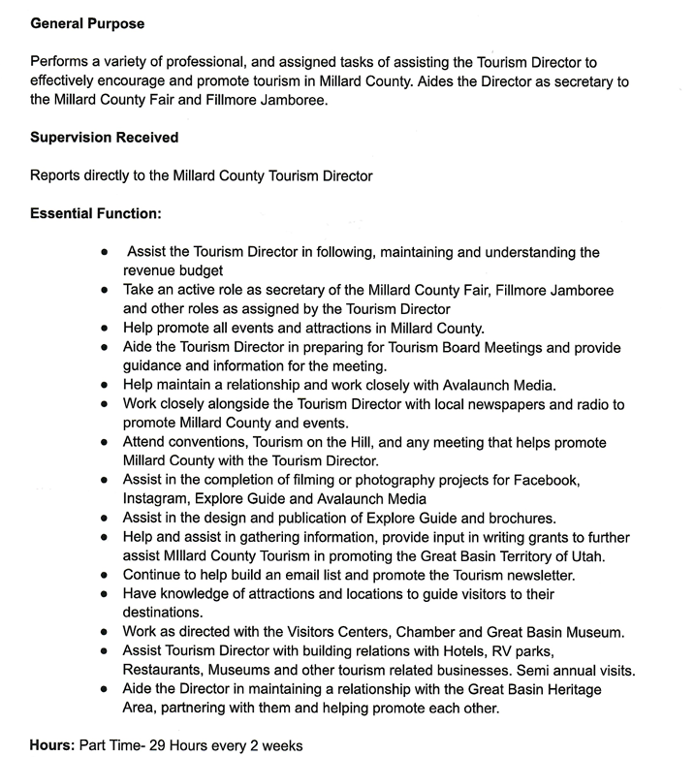

Millard County is an Equal Opportunity Employer and an At-Will Employer

