Courthouse - Fillmore  50 South Main  Fillmore, UT 84631-5504  Fax: (435) 743-8019  Commission Secretary:  (435) 743-6223  Fax: (435) 743-6923 |  | Millard County  www.millardcounty.org
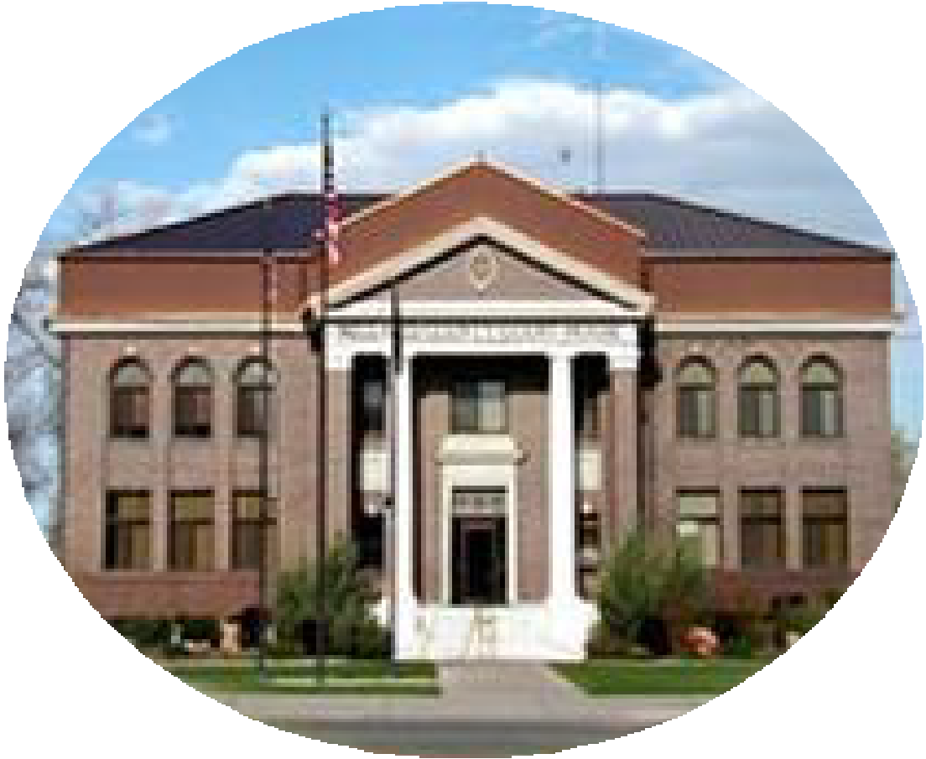 |  | Millard County  www.millardcounty.org
Satellite Offices – Delta
71 South 200 West ◦ P.O. Box 854
Delta, UT 84624
Phone: (435) 864-1400
Fax: (435) 864-1404

Job Announcement:
Millard County Road Department
Millard County is seeking an experienced and safety-focused professional to serve as a Senior Oil Distributor Operator / Heavy Equipment Operator. This position plays a critical role in maintaining county roads and infrastructure while serving as the primary operator of specialized oil distributor trucks used for chip sealing, asphalt preservation, and road maintenance operations.

Position Summary
Under the direction of the Road Supervisor, the successful candidate will operate and maintain oil distributor trucks and a variety of heavy equipment to support road construction, maintenance, repair, and preservation projects throughout Millard County and participating local governments.
This position requires extensive experience in oil distribution operations, heavy equipment operation, roadway maintenance, and safe work practices.

Essential Duties
- Operate oil distributor trucks and spray systems for chip seal and asphalt preservation projects.
- Perform roadway maintenance, repair, and construction activities.
- Operate a variety of heavy equipment including graders, backhoes, excavators, dozers, rollers, water trucks, dump trucks, lowboys, and related equipment.
- Conduct routine equipment inspections, preventative maintenance, and minor repairs.
- Assist with snow removal, road signing, weed control, culvert maintenance, flood control activities, and emergency response operations.
- Provide guidance and training to less experienced operators when assigned.
- Maintain compliance with all county safety standards and operating procedures.

Minimum Qualifications
- Ten (10+) years of experience in oil distribution operations and maintenance of medium and heavy equipment.
- Demonstrated journey-level skill operating heavy equipment and oil distribution systems.
- Ability to safely perform physically demanding outdoor work in varying weather and terrain conditions.
- Ability to read plans, follow instructions, communicate effectively, and work cooperatively with coworkers and the public.

Required Certifications
- Valid Utah Class A Commercial Driver License (CDL), or ability to obtain.
- Ability to pass and maintain required DOT/ICC physical certification.
- Flagger certification, or ability to obtain when required.

Travel Requirements
The successful candidate must be willing to travel and stay overnight as needed to provide contracted oil distribution services under interlocal agreements with participating cities and counties.

Apply Today
Interested applicants should submit a Millard County employment application and any required supporting documents to jnielson@millardcounty.gov no later than June 17th, 2026 by 5:00pm
For complete information regarding duties, qualifications, physical requirements, and conditions of employment, applicants should review the full official job description.
Millard County is an Equal Opportunity Employer.

