Courthouse - Fillmore  50 South Main  Fillmore, UT 84631-5504  Fax: (435) 743-8019  Commission Secretary:  (435) 743-6223  Fax: (435) 743-6923 |  | 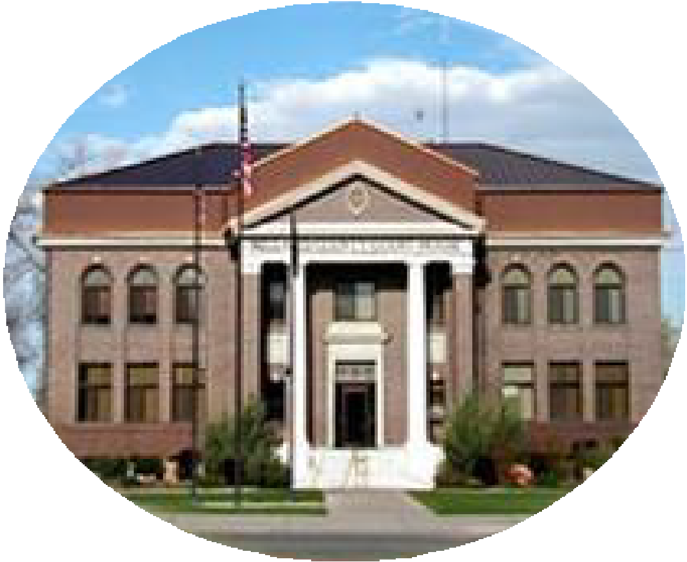  Millard County  www.millardcounty.org
Public Safety Building
765 South HWY, 99
Fillmore, UT 84631

Satellite Offices – Delta
71 South 200 West ◦ P.O. Box 854
Delta, UT 84624
Phone: (435) 864-1400
Fax: (435) 864-1404

Job Posting

Building Inspector

Full-Time - Millard County, Utah
Millard County is seeking a motivated and knowledgeable Building Inspector to join our Community Development team. This position offers the opportunity to work independently, travel throughout one of Utah’s most scenic rural counties, and help ensure residential and commercial construction is safe, code-compliant, and built to last.

Job Responsibilities-
- Perform residential and commercial building inspections.
- Verify compliance with Utah building codes, approved plans, and permit requirements.
- Document inspection results and issue correction notices when necessary.
- Work with contractors, homeowners, and design professionals to promote safe construction.
- Travel throughout Millard County to inspect projects in both urban and rural communities.
- Maintain inspection records using electronic permitting software.

Minimum Qualifications
- High school diploma or equivalent.
- Three (3) years of experience in construction, a skilled trade, construction management, inspection, or a related field.
- Ability to read construction plans and understand modern building practices.
- At least one current ICC Inspector Certification at the time of hire.
- Valid Utah Driver License with an acceptable driving record.
- Commitment to obtaining additional certifications as required.
See full Job Description for all qualifications and responsibilities.

Preferred Qualifications
- Residential and commercial inspection experience.
- Additional ICC certifications or Plans Examiner certification.
- Utah contractor or trade license.
- Experience with electronic permitting systems.

Why Join Millard County?
- Competitive pay based on experience and certifications
- Excellent County benefits, including health insurance and Utah Retirement Systems (URS)
-Paid vacation, sick leave, and holidays
-Professional training and certification opportunities
-Meaningful work serving the residents and communities of Millard County

Apply Today
Submit to: Arichins@millardcounty.gov
- Millard County Employment Application
- Resume
- List of current ICC certifications and Utah licenses (if applicable)
- Three professional references
Salary: Competitive DOE & Qualifications
Open Until Filled – First review of Applications Due Monday, August 10th @ 5:00Pm

