Courthouse - Fillmore  50 South Main  Fillmore, UT 84631-5504  Fax: (435) 743-8019  Commission Secretary:  (435) 743-6223  Fax: (435) 743-6923 |  | 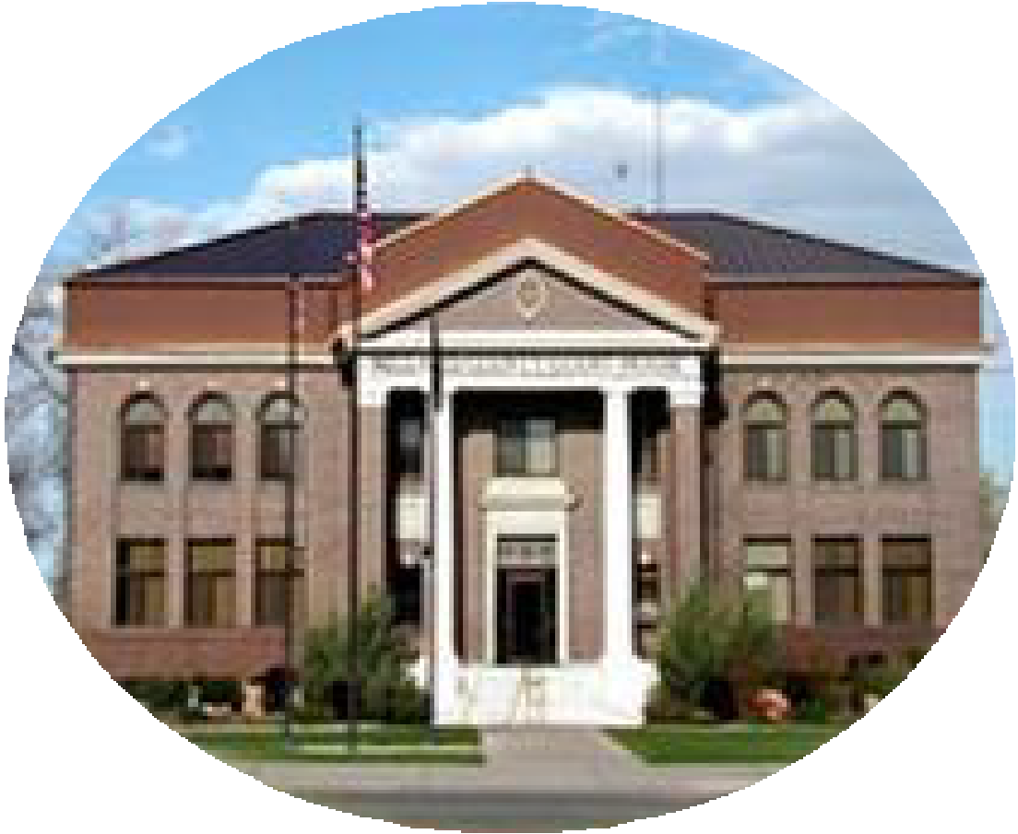  Millard County  www.millardcounty.org
Public Safety Building
765 South HWY, 99
Fillmore, UT 84631

Satellite Offices – Delta
71 South 200 West ◦ P.O. Box 854
Delta, UT 84624
Phone: (435) 864-1400
Fax: (435) 864-1404

Job Announcement
7/29/26

ESSENTIAL FUNCTIONS
The Millard County Maintenance Department has an opening for a very time-flexible part time Custodial/Groundskeeping position: Part Time: Maximum of 29 hours/week. Flexible work schedule with occasional weekend/holiday availability required.

Custodial Duties: As assigned by the Maintenance Supervisor/Asst. Supervisor
• Clean and sanitize restrooms, break rooms, and other common areas. • Sweep, mop, vacuum, and wax floors as needed. • Empty trash and recycling bins and replace liners. • Clean windows, mirrors, and other glass surfaces. • Dust and sanitize furniture, fixtures, and high-traffic areas. • Perform minor maintenance tasks such as changing light bulbs or fixing simple equipment issues. • Monitor and report any damage or needed repairs in the facility.

Groundskeeping Duties: As assigned by the Maintenance Supervisor/Asst. Supervisor
• Mow lawns, trim hedges, and maintain landscaping. • Remove debris, leaves, and trash from outdoor areas. • Ensure walkways, parking lots, and other exterior spaces are clean and safe. • Perform seasonal tasks such as snow removal, salting walkways, or watering plants. • Inspect grounds for hazards and address any issues promptly. • Maintain and service tools and equipment used for groundskeeping tasks.

Starting wage will be starting $17.67-19.03/hr negotiated based on experience and will follow the Millard County Step & Grade Part-time compensation scale.

Applications and a full job description can be found at millardcounty.org. Qualified candidates may submit an application, resume, and a copy of applicants driving record (available at any Utah Driver License Office) to the Millard County recreation office @ 81 Manzanita Ave Delta, Utah or by email to Jnielson@millardcounty.gov by 8/11/2026.

Millard County is an Equal Opportunity Employer

